H.T No
Regulations:
A18

Sreenidhi Institute of Science and Technology
(An Autonomous Institution)
Code No: 7B621 Date: 02-Jan-2025 (AN)

B.Tech III-Year II- Semester External Examination, January-2025 (Supplementary)
CAD/CAM and FEA (ME)

Time: 3 Hours Max.Marks:70

Note: a) No additional answer sheets will be provided.
b) All sub-parts of a question must be answered at one place only, otherwise it will not be valued.
c) Missing data can be assumed suitably.
Bloom's Cognitive Levels of Learning (BCLL)

Remember | L1 | Apply | L3 | Evaluate | L5
Understand | L2 | Analyze | L4 | Create | L6

Part - A Max.Marks:20

Answer all QUESTIONS.

 |  | BCLL | CO(s) | Marks
1 | List the advantages of CAD and CAM. | L1 | CO1 | [2M]
2 | Describe various G and M codes used in CNC machines? | L1 | CO2 | [2M]
3 | How does a CRT work? | L3 | CO3 | [2M]
4 | What are the important applications of FEM? | L2 | CO4 | [2M]
5 | Write the stiffness matrix for two node truss element. | L2 | CO5 | [2M]
6 | Discuss about Ansys software. | L3 | CO6 | [2M]
7 | What is raster scan graphics system? | L2 | CO1 | [2M]
8 | What are the components of CNC machine tools? | L2 | CO2 | [2M]
9 | Explain the significance of Hermite shape functions? | L3 | CO5 | [2M]
10 | Explain shape functions? | L3 | CO6 | [2M]

Part – B Max.Marks:50
ANSWER ANY FIVE QUESTIONS. EACH QUESTION CARRIES 10 MARKS.

 |  |  | BCLL | CO(s) | Marks
11. | a) | What is meant by product life cycle? Describe with a neat sketch. | L2 | CO1 | [5M]
 | b) | Distinguish between C-rep and B-rep models | L2 | CO1 | [5M]
12. | a) | Explain how 2-D and 3-D transformation are done on a graphics element | L3 | CO2 | [5M]
 | b) | Explain the importance of clipping? Give the details of method used for line clipping. | L3 | CO2 | [5M]
13. | a) | Differentiate between manual part programming and computer aided part programming in CNC machines. | L4 | CO3 | [5M]
 | b) | With a block diagram explain main features of CNC machine tools with feedback. | L3 | CO3 | [5M]
14. | a) | List the steps involved with finite element analysis of a typical problem. | L4 | CO4 | [5M]
 | b) | Find displacements and stresses of the bar shown in fig Using finite element method?  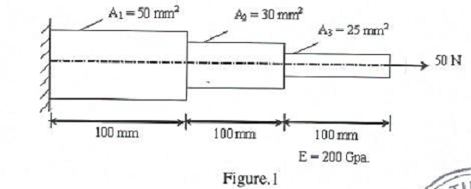 | L1 | CO4 | [5M]
15. | a) | Determine the stiffness matrix of a truss element? | L5 | CO5 | [5M]
 | b) | Find the deflection and slopes and also construct shear force and bending moment diagrams. A beam is fixed at one end and sported by a roller at the other end, has a 20KN concentrated load applied at the centre of the span of 10m. Take I= 2500cm⁴, E=200GPa | L1 | CO5 | [5M]
16. | a) | Consider the axial vibrations of a steel bar shown in fig. Determine the natural frequenciec and mode shapes.  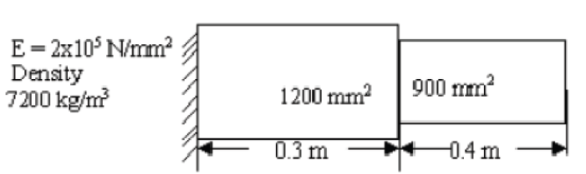 | L5 | CO6 | [5M]
 | b) | List any three Finite element analysis software’s and explain their capabilities. | L1 | CO6 | [5M]
17. | a) | What is the software configuration of a graphics system? | L2 | CO1 | [4M]
 | b) | Explain hidden surface removal. | L3 | CO2 | [3M]
 | c) | What are the components of CNC machine tools? | L2 | CO3 | [3M]
18. | a) | What are shape functions? What are their properties? | L2 | CO4 | [4M]
 | b) | Briefly discuss about the types of trusses. | L2 | CO5 | [3M]
 | c) | Briefly explain the types of mass matrix. | L2 | CO6 | [3M]

-- 00 -- 00 –

